**LAB FINAL**

**NAME:** ABDULLAH RASHEED

**REG:**  FA22-BSE-030

**Question 1**

**Part A**

**Topology**

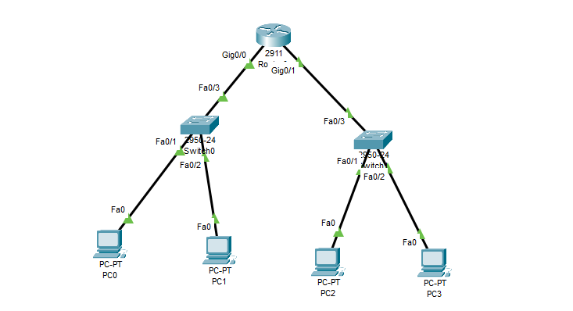

**Router Config:**

Router>enable

Router#

Router#configure terminal

Enter configuration commands, one per line. End with CNTL/Z.

Router(config)#interface GigabitEthernet0/0

Router(config-if)#no shutdown

Router(config-if)#

%LINK-5-CHANGED: Interface GigabitEthernet0/0, changed state to up

%LINEPROTO-5-UPDOWN: Line protocol on Interface GigabitEthernet0/0, changed state to up

Router(config-if)#

Router(config-if)#exit

Router(config)#interface GigabitEthernet0/1

Router(config-if)#no shutdown

Router(config-if)#

%LINK-5-CHANGED: Interface GigabitEthernet0/1, changed state to up

%LINEPROTO-5-UPDOWN: Line protocol on Interface GigabitEthernet0/1, changed state to up

Router(config-if)#

Router(config-if)#exit

Router(config)#interface GigabitEthernet0/0

Router(config-if)#ip address 192.168.1.1 255.255.255.0

Router(config-if)#ip address 192.168.1.1 255.255.255.0

Router(config-if)#

Router(config-if)#

Router(config-if)#exit

Router(config)#interface GigabitEthernet0/0

Router(config-if)#ip nat source static 192.168.1.1 255.255.255.0 200.0.0.1

Router(config)#interface GigabitEthernet0/1

Router(config-if)#ip nat source static 192.168.1.2 255.255.255.0 200.0.0.2

**Switch Config**

Switch>enable

Switch#

Switch#configure terminal

Enter configuration commands, one per line. End with CNTL/Z.

Switch(config)#

Switch(config)#vlan 10

Switch(config-vlan)# name a

Switch(config-vlan)#

**Part B**

**A)**

**First Handshake:**

**PACKET:** 51

**Source Port:** 53406

**Destination:** 80

**FLAG:** 0x002 (SYN

**Seq Number:** 0

**ACK Number:** 0

**Second Handshake**

**PACKET:** 75

**Source Port:** 80

**Destination:** 53406

**FLAG:** 0x012 (SYN ACK)

**Seq Number:** 0

**ACK Number:** 1

**Third Handshake**

**PACKET:** 77

**Source Port:** 53406

**Destination:** 80

**FLAG:** 0x010 (ack)

**Seq Number:** 1

**ACK Number:** 1

**B)**

83 Segmemt is 1 HTTP POST SEGMENT

LENGTH: 708

Seq Num : 1

**C)**

Packet One (Segment 115 ACK:18229) Time Difference = 6.533486 – 6.070103 = 0.463383

Packet Two(Segment 119 ACK: 24069) TIME DIFFERENCE = 0.49

Packet Three(Segment 120 ACK: 25529) TIME DIFFERENCE = 0.49

Packet Four(Segment 125 ACK:32829) Time Difference = 0.523741

Packet Five (Segment 126 ACK: 34289) TIME DIFFERENCE = 0.591889

**ESTIMATED RTT**

**ESTIMATED RTT = ESTIMATED RTT * 0.875 + 0.125* SAMPLE RTT**

**Packet 1 :** 0.463383000

**Packet 2:** 0.463383

**Packet 3:** 0.466710125

**Packet 4:** 0.4696213594

**Packet 5:** 0.5350889844

**Packet 6:** 0.609075234

**D)**

No

**E)**

**Throughput = data/time**

**Total Data =** 2303286-1 = 2303285

**Total Time =** 10.366449 – 5.260700 = 5.105749

**Throughput = 2303285 / 5.105749 = 451115.9871**

**F)**

Minimum Buffer Space = 29200

**G)**

Length of all packets is 1460

**Question 2**

**Server Code:**

import java.io.*;

import java.net.*;

public class WordCountServer {

    public static void main(String[] args) {

if (args.length < 1)

return;

int port = Integer.parseInt(args[0]);

try (ServerSocket serverSocket = new ServerSocket(port)) {

        System.out.println("Server is listening on port " + port);

        while (true) {

                Socket socket = serverSocket.accept();

                System.out.println("New client connected");

                new WordCountHandler(socket).start();

            }

        } catch (IOException e) {

            System.out.println("Server exception: " + e.getMessage());

            e.printStackTrace();

        }

    }

}

**Client Handler:**

import java.net.*;

import java.io.*;

public class WordCountHandler extends Thread{

    private Socket socket;

    public WordCountHandler(Socket socket){

        this.socket = socket;

    }

    public void run(){

        try{

            InputStream input = socket.getInputStream();

            BufferedReader reader = new BufferedReader(new InputStreamReader(input));

            OutputStream output = socket.getOutputStream();

            PrintWriter printer = new PrintWriter(output,true);

            String text;

            do {

                text = reader.readLine();

                int numwords = countWords(text);

                printer.println(numwords);

            }while (!text.equals("exit"));

            socket.close();

        }catch (IOException is){

            System.out.println("IO Exception");

        }

    }

    private int countWords(String input)

    {

        String [] word = input.trim().split(" ");

        return word.length;

    }

}

**Client Code:**

import java.net.*;

import java.io.*;

public class WordCountClient {

    public static void main(String[] args) {

        if (args.length < 2){

            return;

        }

        String host = args[0];

        int port = Integer.parseInt(args[1]);

        try{

        Socket socket = new Socket(host,port);

        InputStream input = socket.getInputStream();

        BufferedReader reader = new BufferedReader(new InputStreamReader(input));

        OutputStream output = socket.getOutputStream();

        PrintWriter writer = new PrintWriter(output,true);

        Console console = System.console();

        String text;

        do {

            text = console.readLine();

            writer.println(input);

            String vowel = reader.readLine();

            System.out.println(vowel);

        }while (!text.equals("exit"));

        socket.close();

        }

        catch (IOException io){

            io.printStackTrace();

        }

    }

}